**3-Axis Accelerometer**

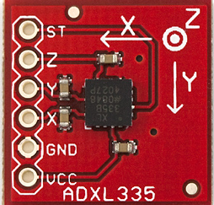

**What It Does**: The accelerometer measures acceleration in all three axes of movement. Acceleration is the change in the speed of an object. It’s the feeling of being pushed into your seat on an airplane during take, or being pushed to one side when a car makes a sharp turn.

**What It Tells You**: Force is related to acceleration by the mass of an object. If the accelerometer is hit, bumped, or dropped, it will know from what direction and by how much it was disturbed. Also, the accelerometer can determine how much it has been rotated around each axis. Tilt is commonly used to do motion capture for video games, commonly on the Nintendo Wii.

**Required Connections:** There are several pins on the accelerometer that require a connection. There are five pins in total, one each for power and ground, and three for each axis of motion.  
  
VCC: Connect to a **3.3V** Supply on the Arduino (Note: a 5V supply will destroy the accelerometer)  
GND: Connect to a **Ground/GND** pin on the Arduino  
X: is the pin providing information on X-axis acceleration; attach to an **Analog Input**Y: is the pin providing information on Y-axis acceleration; attach to an **Analog Input**Z: is the pin providing information on Z-axis acceleration; attach to an **Analog Input**

**Using the Accelerometer in Scratch:**

Use a *value of sensor* block to read in from the selected Analog Input. You will need on block for each axis. Adjust the pull down menu in the block to select the proper pin.

E:\My Dropbox\PhD\IDSA Workshop\Images\valueOfBlock.png

Figure 1: Read Data from Analog Input 0

Also, it will be helpful to store the reading into an appropriately named variable.

E:\My Dropbox\PhD\IDSA Workshop\Images\readInVariableExample.png

Figure 2: Read Sensor Measurement into a Variable

The raw reading from the accelerometer can be converted to a physical value. For the accelerometer this physical value is “g”, where 1 g corresponds to the normal force of gravity. Two g’s would be double...etc. The blocks below convert the raw data into “g’s” in Scratch:

E:\My Dropbox\PhD\IDSA Workshop\Images\accelConversion.png

Figure 3: Convert the Raw Value into a Physical Unit

In addition to acceleration, we can also determine the amount of rotation about each axis. The example below uses the *atan* block, found in the Operators Menu, to determine the rotation about all three axis.

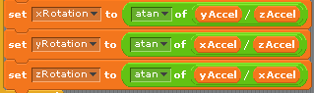

Figure 4: Using atan to Calculate Rotation About Each Axis